Archaeology Industry Working Group
4 May 2020 Statement on Promoting a Safe Working Environment on Construction Sites during the COVID-19 Pandemic
The Industry Working Group is determined to ensure that archaeological work does not pose a threat to the safety and well-being of archaeologists and their families, other workers or the wider public during the Coronavirus crisis. Doing so will help to reduce pressure on health services and save lives.
The IWG notes that CIfA accredited members and Registered Organisations have a duty of care to employees, colleagues and volunteers under Principle 5 of the Code of conduct and that FAME’s commitment to improving the business environment for archaeological companies includes the prioritisation of the well-being of staff in the sector.
The IWG notes the concerns raised by Prospect, Unite and others in relation to the 14 April 2020 version of the Site Operating Procedures issued by the Construction Leadership Council which have had the effect of reducing the level of protection afforded to everyone working on construction sites during the COVID-19 pandemic.
The IWG also notes that on 4 May 2020 Prospect published revised guidance for archaeologists working on construction sites which seeks to mitigate the union’s concerns and promote a safe working environment. The IWG is recommending that consideration should be given to using the Prospect guidance as support for the development of workplace agreements (between employers and trade unions) and / or as supporting text in the preparation of local Site Operating Procedures across the sector.

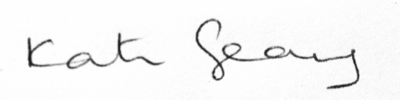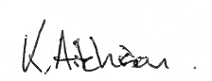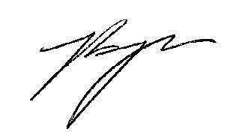
KATE GEARY KENNETH AITCHISON JESSICA BRYAN
Head of Professional Development & Practice Chief Executive Officer Chair, Archaeologists Branch
Chartered Institute for Archaeologists Federation of Archaeological Managers & Employers Prospect

The following organisations, who sit on the Archaeology Industry Working Group as observers, have also endorsed this statement: British Archaeological Jobs Resource and CIfA Diggers’ Forum.

